**12 Stochastic epidemic models**

**PART I: DTMC model**

Plot sample paths in the following cases:

1. DTMC SIS model $N=100, ∆t=0.01, β=1, b=0.25, γ=0.25, I(0)=2$

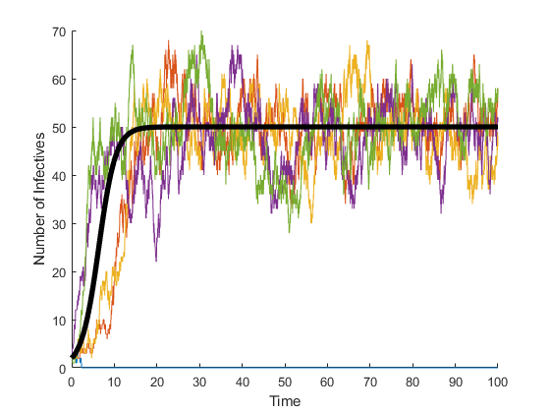

1. DTMC SIS model $N=100, ∆t=0.01, β=0.25, b=0.25, γ=0.25, I(0)=20$

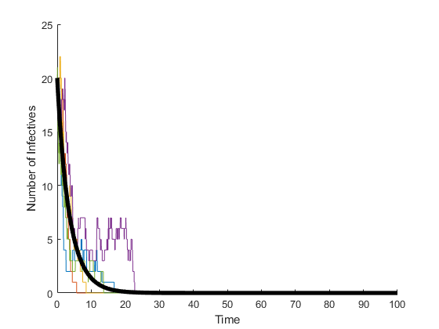

1. DTMC SIR model $N=100, ∆t=0.01, β=1, b=0, γ=0.5, I(0)=2$

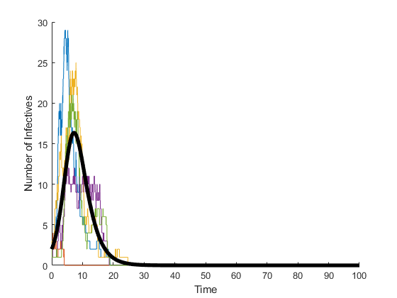

1. DTMC SIR model $N=100, ∆t=0.01, β=1, b=0.25, γ=0.25, I(0)=2$

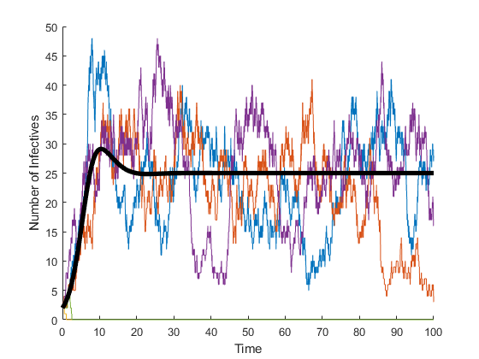

1. Discuss the above results in terms of parameters and model.

Comparing the basic reproduction number, $R_{0}$, for each case, we can expect whether the number of infectious would die out or not in deterministic model. The $R_{0}$ s for Q1, Q3, and Q4 are all 2 but Q2 has 0.5 which is less than 1. Therefore, we can see the solution from deterministic model dies out with Q2 parameter set, which shows sample paths from stochastic models have the same tendency in terms of outbreak.

Among the cases whose $R_{0}>1$, they have the different dynamics in terms of birth rate. When there’s a birth rate, endemic equilibrium occurs, which the number of infectious remains positive. Moreover, when we observe the sample paths from stochastic model, these endemic equilibrium goes dynamically, not stationary. Some sample paths die out when the number of infectious goes to zero, which implies the necessity of quasi-stationary states instead of stationary states of deterministic system.

1. Plot the graph of the probability of an outbreak as a function of time for different initial infectives $i_{0}=1, 2, 3$. Use the same values for other parameters and model as in Q1. Compare the results from 1000 sample paths and the ones with the formula using transition matrix.

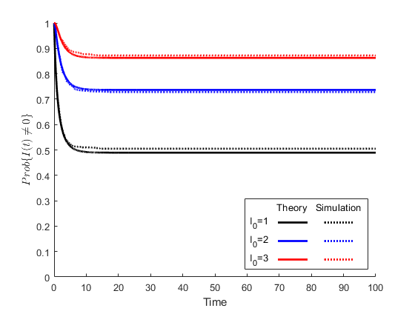

The probability of an outbreak can be represented as $Prob\{I\left(t\right)≠0\}$. We can see the theoretical probability and numerical simulation are well-fit. As an approximation, we studied the probability is about $1-{\left(\frac{1}{R_{0}}\right)}^{I_{0}}$. Because $R_{0}=2$ with Q1 parameter set, we can easily see the approximation. The slight difference can be described as the assumption for approximation which is the small initial infective with large enough population.

1. Repeat the Q5 for different values of $R_{0}=0.5, 2, 5$ by varying the values of $β$ with the initial infective $i_{0}=2$.

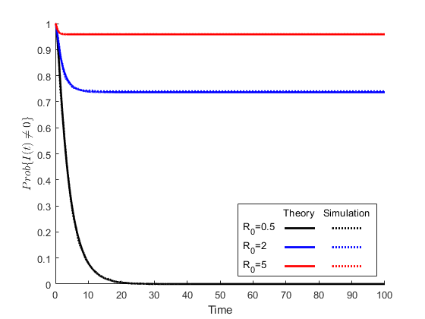

The larger $R_{0}$ the parameter set has, the larger the probability of outbreak is. We can evaluate $β$ as $R_{0}(b+γ)$ from the following formula.

$$R_{0}=\frac{β}{b+γ}$$

**PART II: CTMC model**

Plot sample paths in the following cases:

1. CTMC SIS model $N=100, β=1, b=0.25, γ=0.25, I(0)=2$

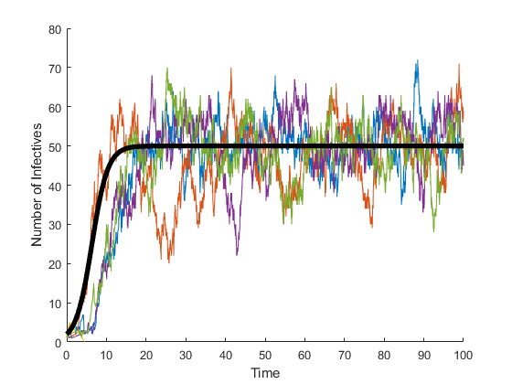

1. CTMC SIS model $N=100, β=0.25, b=0.25, γ=0.25, I(0)=20$

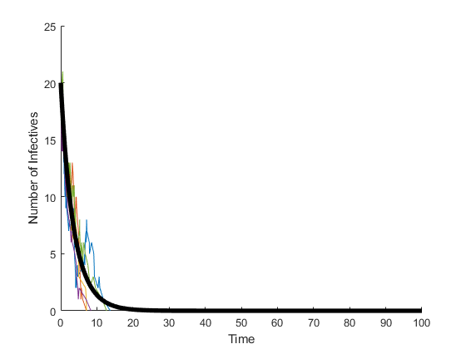

1. CTMC SIR model $N=100, β=1, b=0, γ=0.5, I(0)=2$.

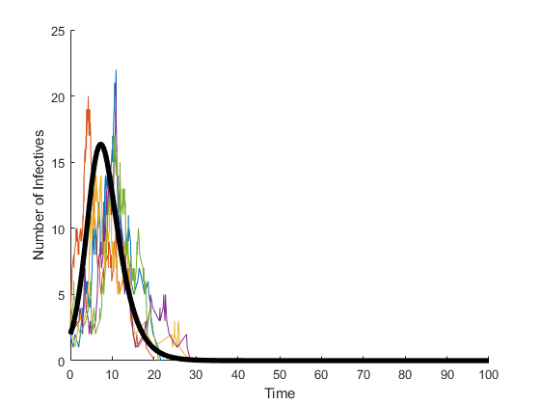

1. CTMC SIR model $N=100, β=1, b=0.25, γ=0.25, I(0)=2$

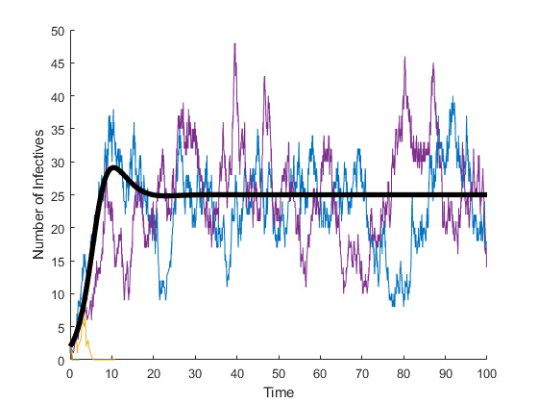

1. Discuss the above results in terms of stochastic process.

Unlike the DTMC process, CTMC has slightly different assumption for time step. DTMC has small but uniform time step assuming that only one event can occur in it. On the other hand, CTMC has different time step for each step determined by Gillespie algorithm, which can be real number and makes different shape of sample paths.

1. Plot the quasistationary probability distribution under the setting of Q1.

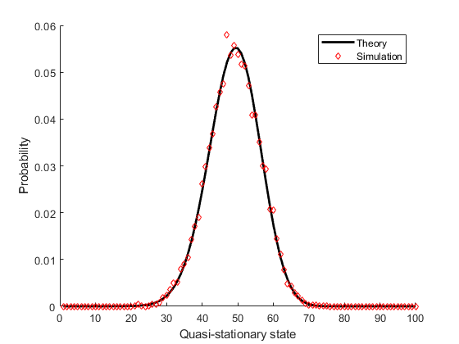

1. Run the CTMC SIR model with $N=20, b=0, γ=0.5, I\left(0\right)=1$ to plot the graph of final size distribution for different values of $R_{0}=0.5, 2, 5$.

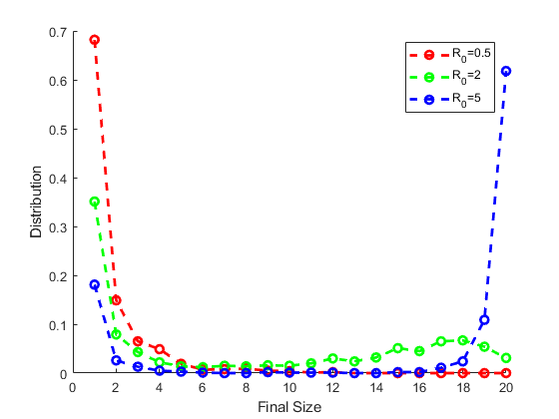

As $R_{0}$ grows up, we expected the higher final size, which is shown on the above graph. It is noteworthy that the final size distribution can be given from the stochastic process. With the deterministic compartment model, final size is also determined by the $R_{0}$. Moreover, it is noticeable that, even if $R_{0}=2>1$, the cases of one final size, which means no outbreak occur, is the most frequent. This can be more studied with stochastic process theories with various $R_{0}$.